|  |  |
| --- | --- |
| TEAM ID | **PNT2022TMID53615** |
| PROJECT NAME | **SMART SOLUTION FOR RAILWAYS** |

# PROJECT DEVELOPMENT DELIVERY OF SPRINT-4

**SPRINT-4**

STEPS TO BE DONE

1. Tracking train in map
2. Getting phone number and sending SMS
3. Creating JIRA account and adding all members in it
4. Creating testcases and assigning
5. Moving testcases to all Done once checked

# NODE_RED:

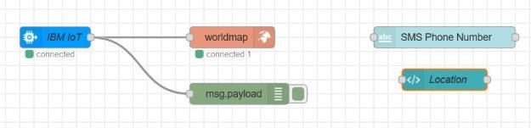

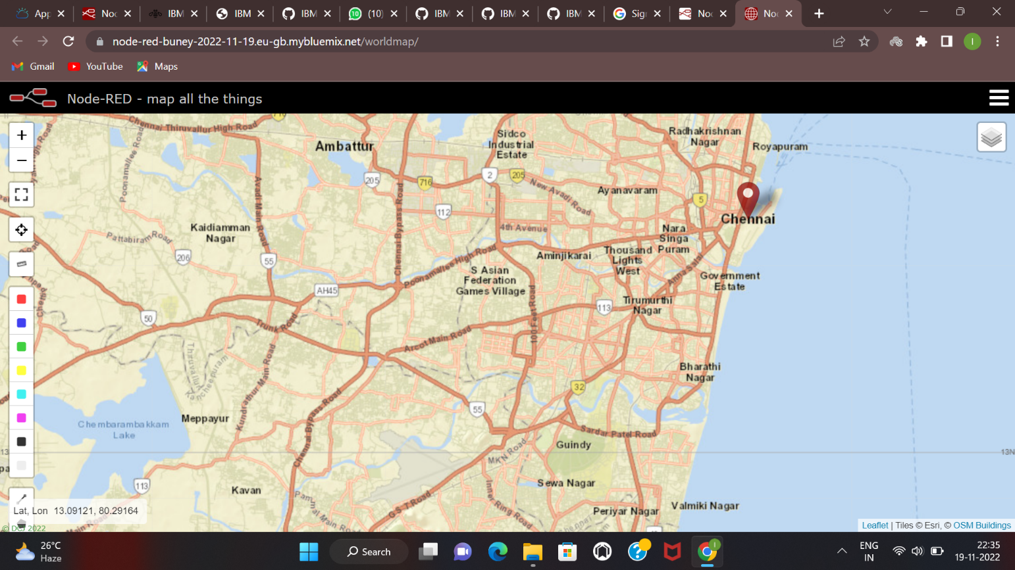

**Getting Phone number and SMS:**

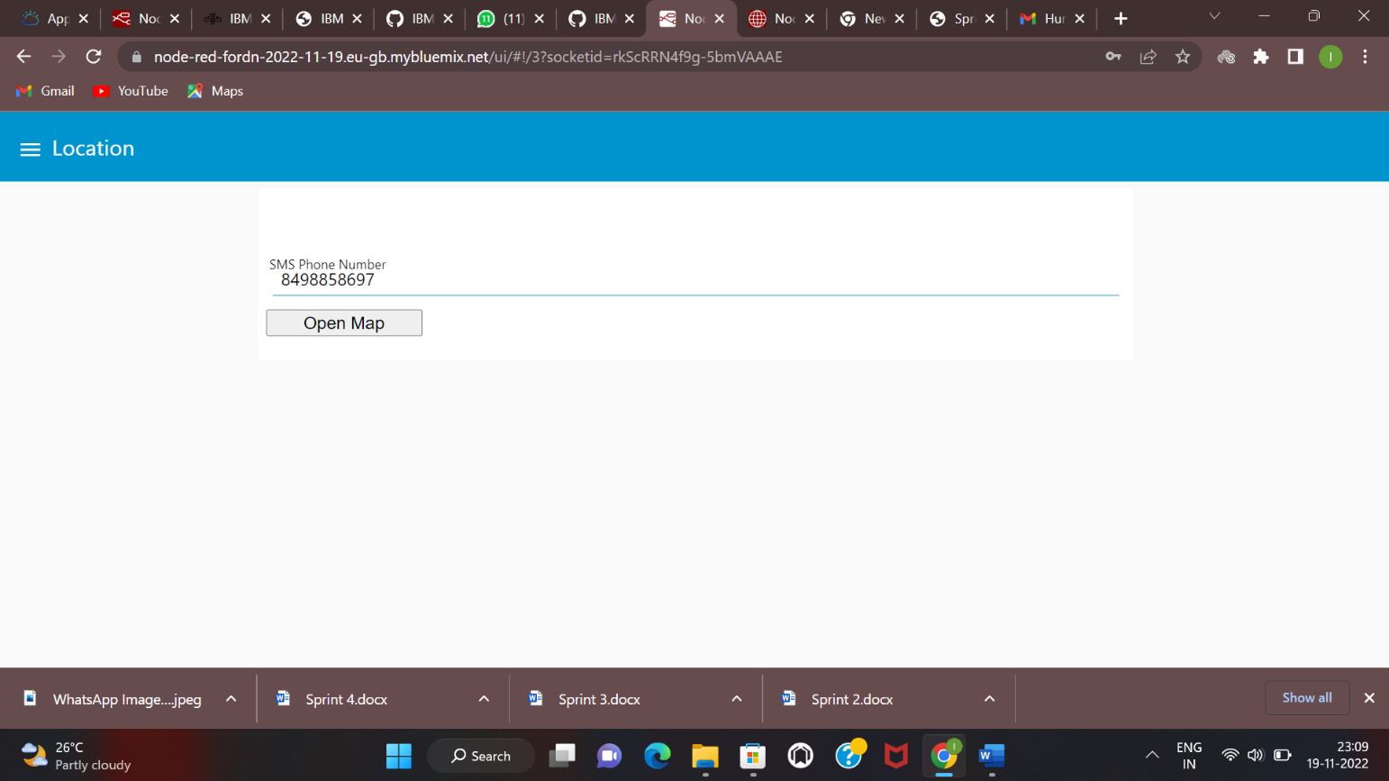

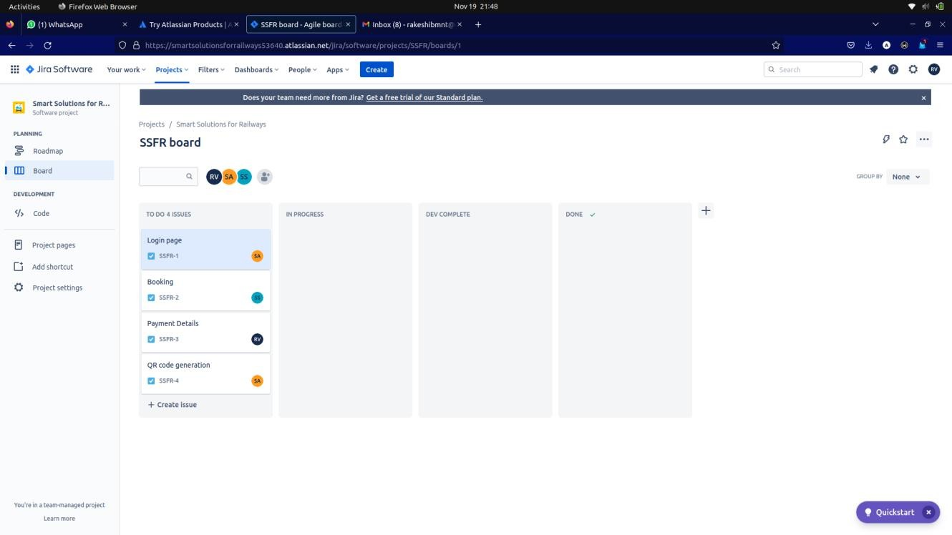

# TESTCASE CREATION

